

**North South University**

**Department of Electrical & Computer Engineering**

**LAB REPORT**

**Analog Electronics Lab**

**EEE111L**

**Experiment Number: 5**

**Experiment Name:** The Input-Output characteristics of CE (common emitter) configuration of BJT

**Experiment Date:** 22/11/2021

**Report Submission Date:** 29/11/2021

**Section:** 7 **Group No:** 2

**Students Name & ID:**

1. Md. Rifat Ahmed – 193172504 **(Report Writer)**
2. Yusuf Abdullah Tonmoy – 1620456042
3. Fardin Bin Islam – 1721588642
4. Md Kawser Islam – 1912296642
5. Tusher Saha Nirjhor – 1921793642

|  |  |  |
| --- | --- | --- |
| **Remarks:** | Score |  |
|  |  |
|  |  |  |
|  |  |  |

**Objectives:**

• Our objective in this experiment is to study the input-output characteristics of CE (common emitter) configuration of BJT.

**Theory:**

**Emitter:**

In comparison to the two base and collector terminals, the emitter terminal is the most severely doped. Because the emitter's job is to send the charge carrier to the collector via the base, this is the case. The emitter is larger than the base, but smaller than the collector.

**Base:**

The base region is exceedingly tiny, being smaller than both the emitter and the collector. The base is always kept small to ensure that charge carriers entering the base from the emitter do not recombine in the base region and are guided to the collector region. The base has a lower doping intensity than the emitter and collector for the same reason as the emitter and collector.

**Collector:**

Because all of the charge carriers from the emitter recombine at the base, heat is emitted, the collector terminal is moderately doped, and the collector zone is slightly larger than the emitter region. As a result, the collector terminal must be large enough to disperse the heat and prevent the gadget from burning out.

**Input Characteristic Curve:**

The curve plotted between base current IB and the base-emitter voltage VEB is called the Input characteristics curve. For drawing the input characteristic, the reading of base currents is taken through the ammeter on emitter voltage VBE at constant collector-emitter current. The curve for different values of collector-base current is shown in the figure below.

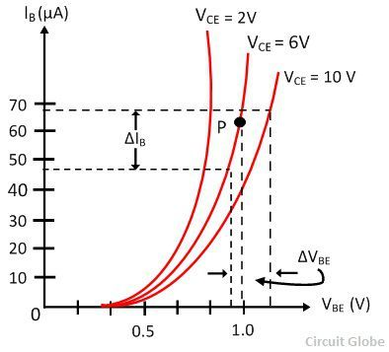

Input Characteristic Graph

The curve for common base configuration is similar to a forward diode characteristic. The base current IB increases with the increases in the emitter-base voltage VBE. Thus, the input resistance of the CE configuration is comparatively higher than that of CB configuration.

The effect of CE does not cause a large deviation on the curves, and hence the effect of a change in VCE on the input character is ignored.

**Input Resistance:**

The ratio of change in base-emitter voltage VBE to the change in base current ΔIB at constant collector-emitter voltage VCE is known as input resistance RI, i.e.

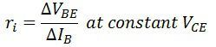

**Output Characteristic**:

The output characteristic of a CE setup is the curve drawn between collector current IC and collector-emitter voltage VCE at a constant base current IB. The image below depicts the characteristic curve of a typical NPN transistor in CE form.

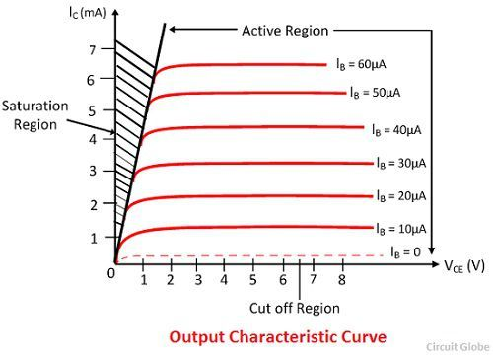

The collector current increases slightly when the collector-emitter VCE current grows in the active zone. The curve has a steeper slope than the output characteristic of the CB arrangement. The common base connection has a higher output resistance than the CE connection.

With an increase in VCE at constant voltage IB, the value of the collector current IC rises, and the value of likewise rises.

When the VCE declines, the IC drops rapidly as well. The transistor's collector-base junction is always forward biased and work saturate. The collector current becomes independent of the input current IB in the saturation region.

A little current IC is not zero in the active zone IC = IB, and it is equal to reverse leakage current ICEO.

**Output Resistance:**

The output resistance RO is defined as the ratio of the fluctuation in collector-emitter voltage to the collector-emitter current at constant base current IB and the output resistance of the CE configuration is higher than that of the CB configuration.

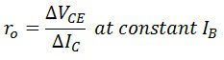

**Equipment List:**

• Transistor (C828) – 1 piece

• Resistor (100kΩ, 1kΩ) – 1 piece each

• Trainer Board

• DC Power Supply

• Digital Multimeter

• Cords and wires

**Circuit Diagram:**

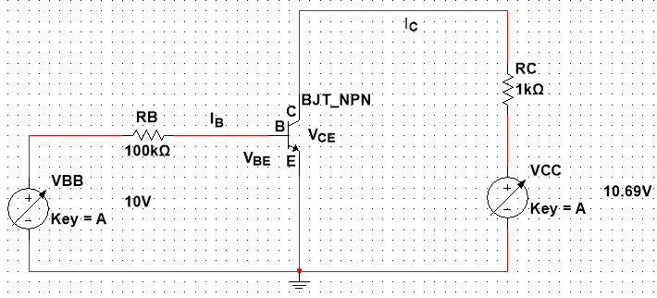

Figure – 1: BJT NPN Transistor Circuit

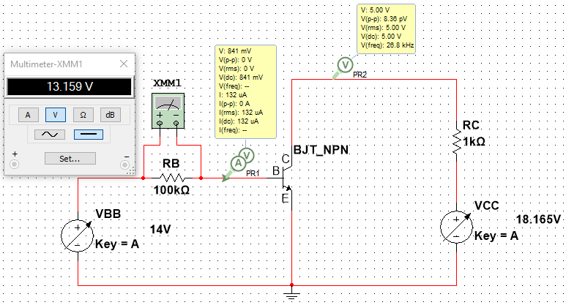

Figure 2 – Circuit to get the values for the Input characteristics of BJT

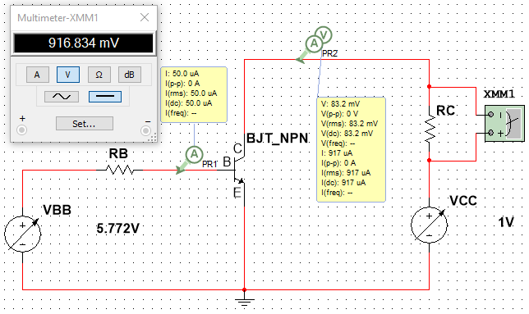

Figure 3 – Circuit to get the values for the Output characteristics of BJT

**Data & Table:**

### Table 1: Input Characteristics of BJT

|  |  |  |  |  |  |  |  |
| --- | --- | --- | --- | --- | --- | --- | --- |
| $V_{CE }$ = 1 V | | | | $V_{CE }$ = 5V | | | |
| $V_{BB}$**(Volts)** | $V_{BE }$**(Volts)** | $V_{RB }$**(Volts)** | $${ I}_{B}=V_{RB }/R_{B}$$ (**μA)** | $V_{BB}$**(Volts)** | $V_{BE }$**(Volts)** | $V_{RB }$**(Volts)** | ${ I}_{B}=V_{RB }/R_{B}$ (**μA)** |
| 0.1 | 100mV | 0V | 0A | 0.1 | 100mV | 0V | 0A |
| 0.2 | 200mV | 0V | 0A | 0.2 | 200mV | 0V | 0A |
| 0.3 | 300mV | 0V | 0A | 0.3 | 300mV | 0V | 0A |
| 0.4 | 400mV | 0V | 0A | 0.4 | 400mV | 0V | 0A |
| 0.5 | 200mV | 0.025mV | 0A | 0.5 | 500mV | 0.024mV | 0A |
| 0.6 | 599mV | 1.137mV | 0A | 0.6 | 599mV | 1.136mV | 0A |
| 0.7 | 677mV | 23.168mV | 0A | 0.7 | 677mV | 23.168mV | 0A |
| 0.8 | 711mV | 88.503mV | 0.89µA | 0.8 | 711mV | 88.502mV | 0.89µA |
| 0.9 | 729mV | 171.406mV | 1.71µA | 0.9 | 729mV | 171.406mV | 1.71µA |
| 1.0 | 739mV | 260.573mV | 2.61µA | 1.0 | 739mV | 260.573mV | 2.61µA |
| 1.2 | 753mV | 446.636mV | 4.47µA | 1.2 | 753mV | 446.636mV | 4.47µA |
| 1.4 | 763mV | 637.436mV | 6.37µA | 1.4 | 763mV | 637.436mV | 6.37µA |
| 1.6 | 769mV | 830.59mV | 8.31µA | 1.6 | 769mV | 830.59mV | 8.31µA |
| 1.8 | 775mV | 1.025V | 10.3µA | 1.8 | 775mV | 1.025V | 10.3µA |
| 2.0 | 779mV | 1.221V | 12.2µA | 2.0 | 779mV | 1.221V | 12.2µA |
| 3.0 | 795mV | 2.205V | 22.1µA | 3 | 795mV | 2.205V | 22.1µA |
| 5.0 | 811mV | 4.189V | 41.9µA | 5 | 811mV | 4.189V | 41.9µA |
| 7.0 | 821mV | 6.179V | 61.8µA | 7 | 821mV | 6.179V | 61.8µA |
| 10 | 832mV | 9.168V | 91.7µA | 10 | 832mV | 9.168V | 91.7µA |
| 14 | 841mV | 13.159V | 132µA | 14 | 841mV | 13.159V | 132µA |

Here, we’re considering 0V and 0A for values that are too small like nV, pA, nA.

**Table 2: Output Characteristics of BJT**

|  |  |  |  |  |  |  |
| --- | --- | --- | --- | --- | --- | --- |
|  | ${ I}_{B}$ = 10 **μA** | | | ${ I}_{B}$ = 50 **μA** | | |
| $V_{CC}$**(Volts)** | $V_{CE }$**(Volts)** | $V_{RC }$**(Volts)** | $${ I}_{C}=V_{RC }/R_{BC}$$ (**mA)** | $V_{CE }$**(Volts)** | $V_{RC }$**(Volts)** | $${ I}_{C}=V_{RC }/R_{BC}$$ (**mA)** |
| 0.1 | 51.2mV | 48.81mV | 48.81µA | 31.7mV | 68.252mV | 68.252µA |
| 0.2 | 73.0mV | 126.993mV | 126.993µA | 43.2mV | 156.842mV | 156.842µA |
| 0.3 | 87.5mV | 212.479mV | 212.479µA | 51.6mV | 248.45mV | 248.45µA |
| 0.4 | 98.9mV | 301.07mV | 301.07µA | 58.2mV | 341.795mV | 341.795µA |
| 0.5 | 109mV | 391.104mV | 391.104µA | 63.8mV | 436.23mV | 436.23µA |
| 0.6 | 118mV | 481.824mV | 481.824µA | 68.5mV | 531.477mV | 531.477µA |
| 0.7 | 128mV | 572.499mV | 572.499µA | 72.7mV | 627.274mV | 627.274µA |
| 0.8 | 137mV | 662.671mV | 662.671µA | 76.5mV | 723.484mV | 723.484µA |
| 0.9 | 148mV | 751.580mV | 751.580µA | 80.0mV | 820.026mV | 820.026µA |
| 1.0 | 162mV | 837.847mV | 837.847µA | 83.2mV | 916.834mV | 916.834µA |
| 1.2 | 219mV | 981.124mV | 981.124µA | 89.0mV | 1.111V | 1.111mA |
| 1.5 | 498mV | 1.002V | 1.002mA | 96.6mV | 1.403V | 1.403mA |
| 2.0 | 998mV | 1.002V | 1.002mA | 108mV | 1.892V | 1.892mA |
| 2.5 | 1.5V | 1.002V | 1.002mA | 118mV | 2.382V | 2.382mA |
| 3.0 | 2.0V | 1.002V | 1.002mA | 128mV | 2.872V | 2.872mA |
| 5.0 | 4.0V | 1.002V | 1.002 mA | 202mV | 4.798V | 4.798mA |
| 10.0 | 9.0V | 1.002V | 1.002mA | 5.0V | 4.995V | 4.995mA |
| 15.0 | 14.0V | 1.002V | 1.002mA | 10.0V | 4.995V | 4.995mA |
| 20.0 | 19.0V | 1.002V | 1.002mA | 15.0V | 4.995V | 4.995mA |

**Graphs:**

**Input Characteristics Graph:**

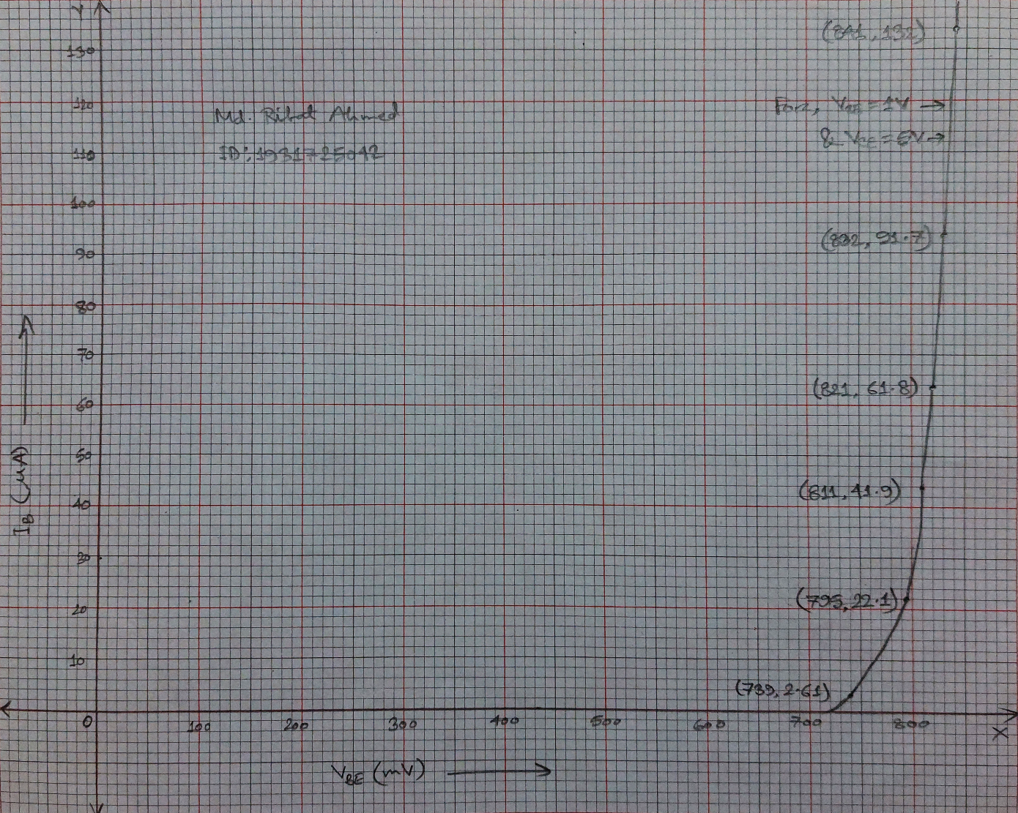

Figure 4 – Input Characteristics Graph of BJT for VCE = 1V & 5V

Here, we got the same values of IB and VBE for the given points for both VCE = 1V & 5V while simulating so the same line is representating both of them.

**Output Characteristics Graph:**

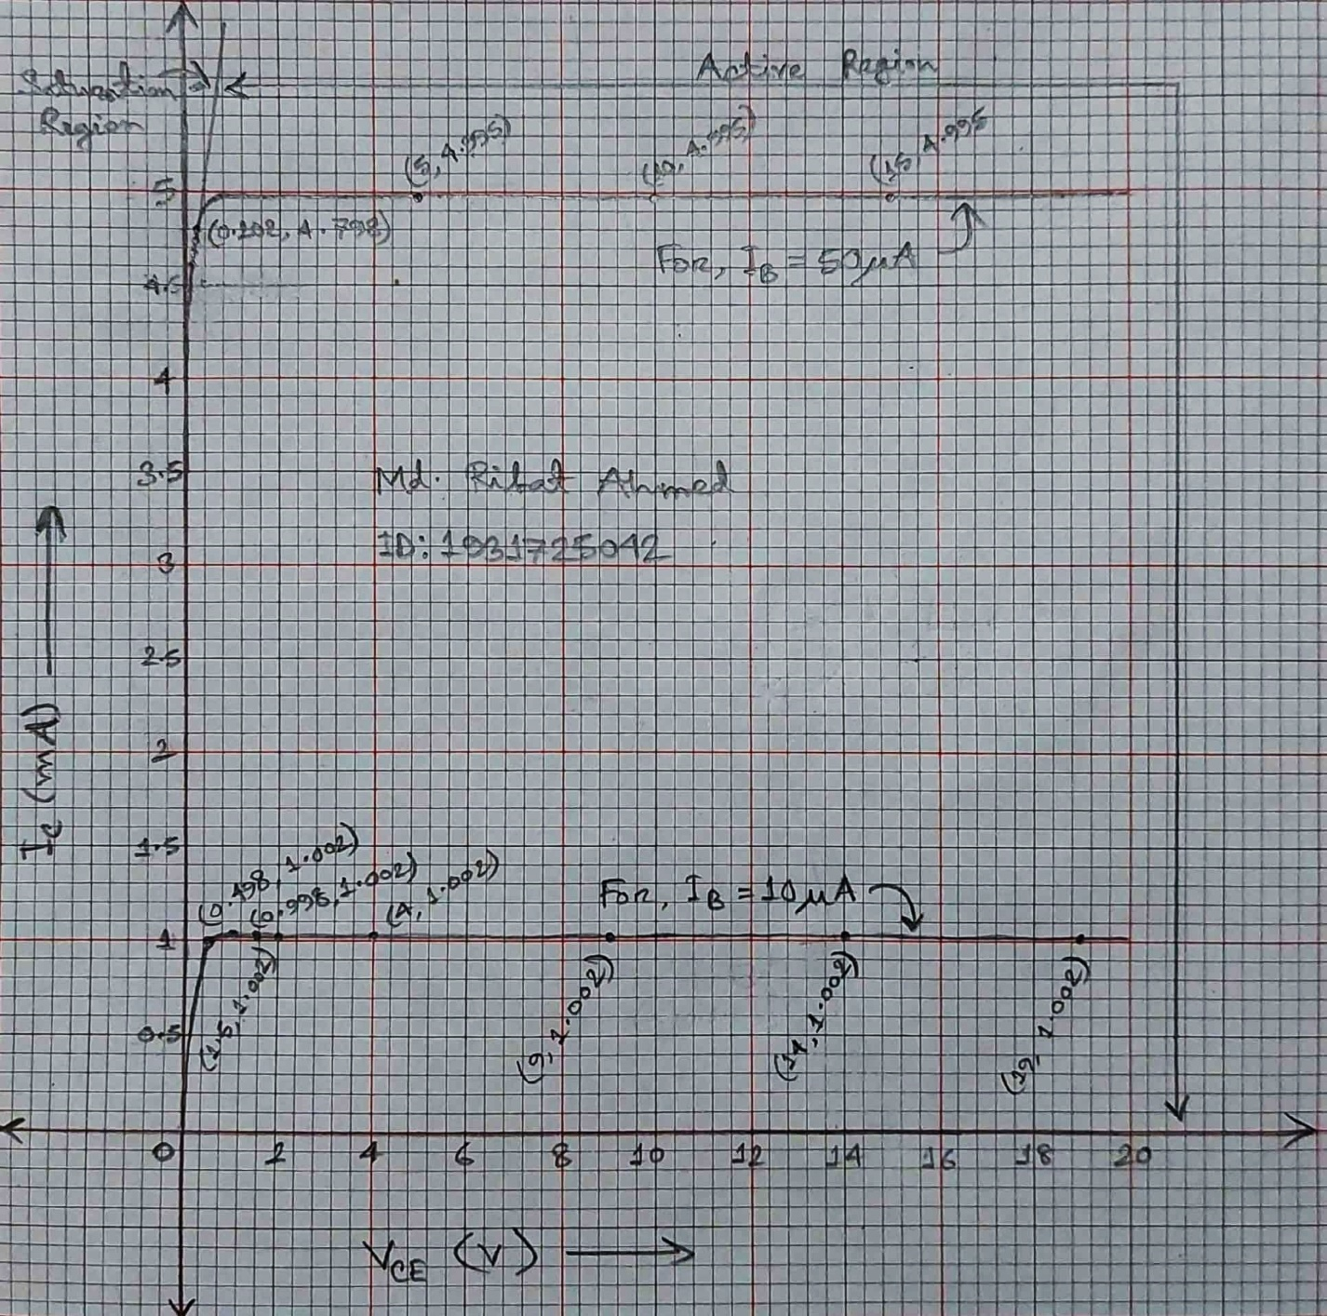

Figure 5 – Output Characteristics Graph of BJT for IB = 10µA & 50µA

**Result Analysis & Discussion:**

In this experiment we have learn about the Input Output characteristic of common emitter. Basically, a transistor is made of these 3 parts called base, collector and emitter. Base is the gate controller for the large electrical supply. Collector is the main power source and the Emitter is the outlet for that power supply. Basically, the input characteristic describes the relation between input current or base current with the input voltage. From the input characteristic we have seen that the base emitter voltage and the base current are 1V and 5V. If we increase VBB from 1V we have find out the active region and VBB is constant there. And the output characteristic describes the relation between output current and the output voltage. In terms of output characteristic, we have seen the effects on Collector Emitter voltage VCE. By slowly increasing VCC, we get the reading for the output curve and there are two region there saturation region where it doesn’t conduct and the active region where we get the output curves.

**Questions / Answers:**

**Answer to question 1:**

Plotting IB vs VBE graph for different VCE:

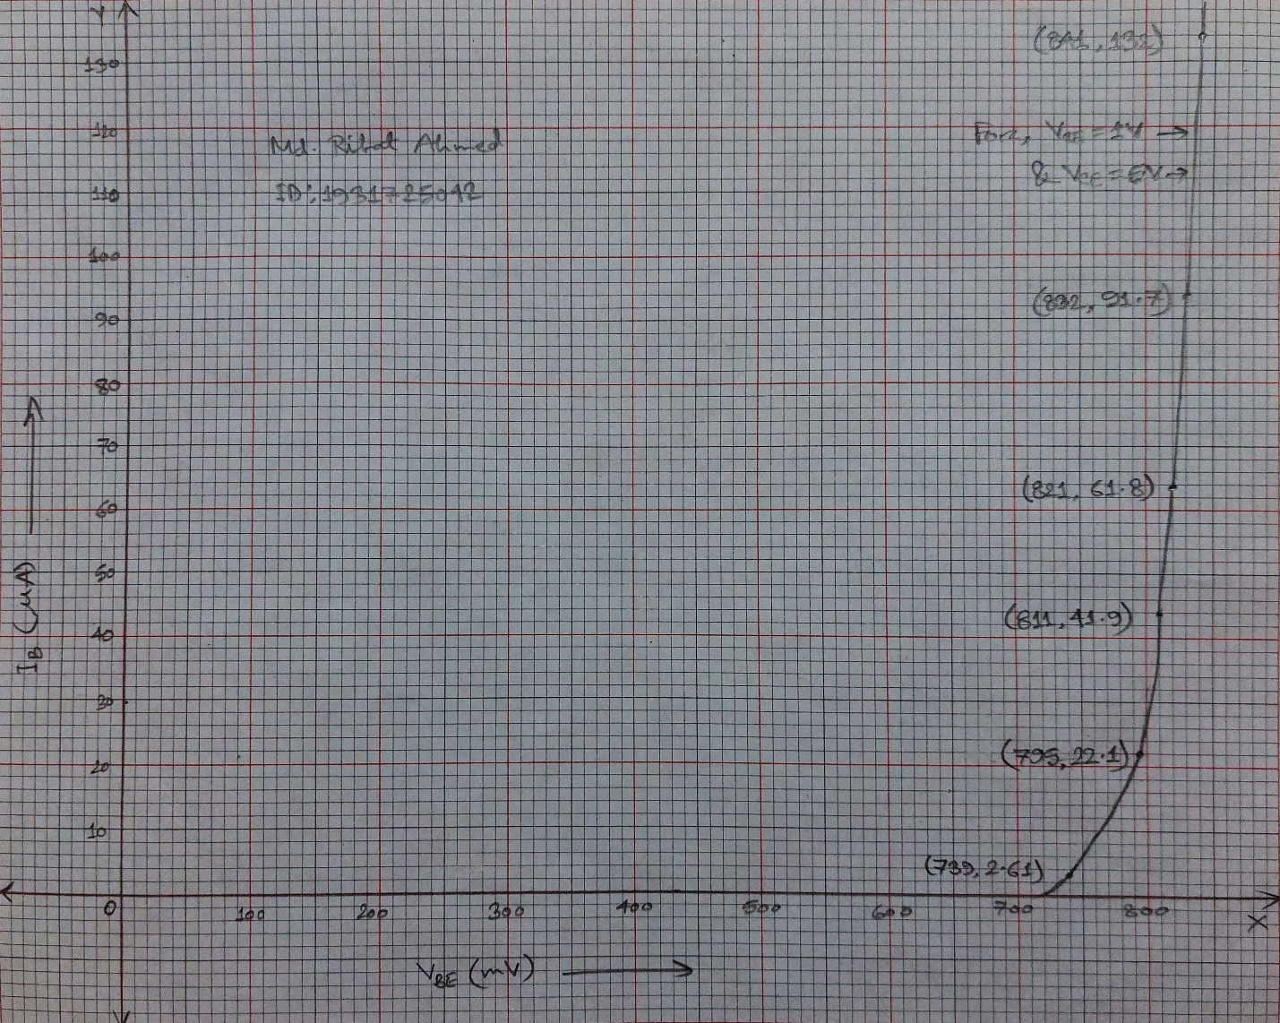

Here, we got the same values of IB and VBE for the given points for both VCE = 1V & 5V while simulating so the same line is representating both of them.

**Answer to question 2:**

Plotting IC vs VCE graph for different IB:

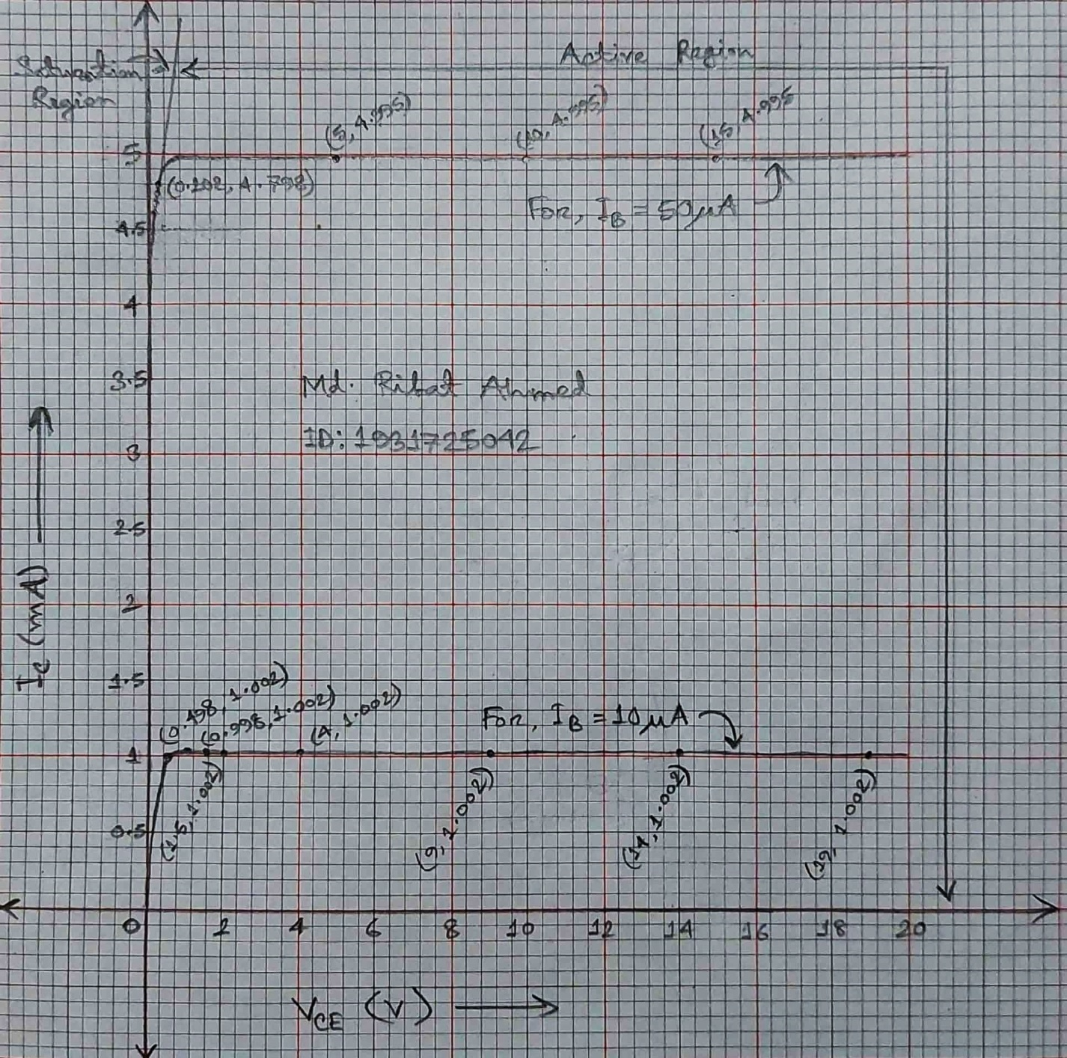

**Answer to question 3:**

Finding β for each IB in the active region:

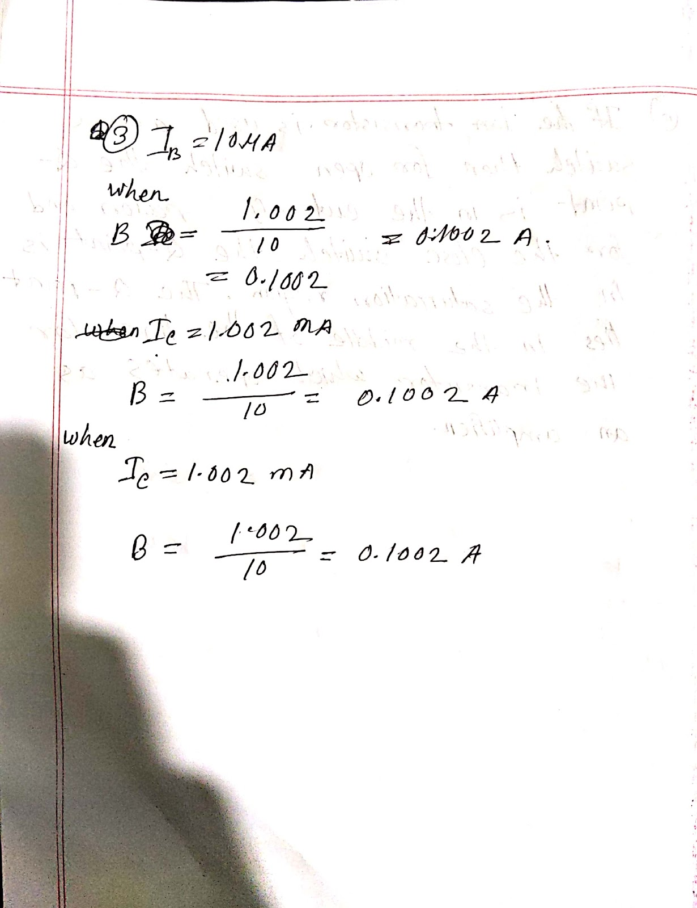

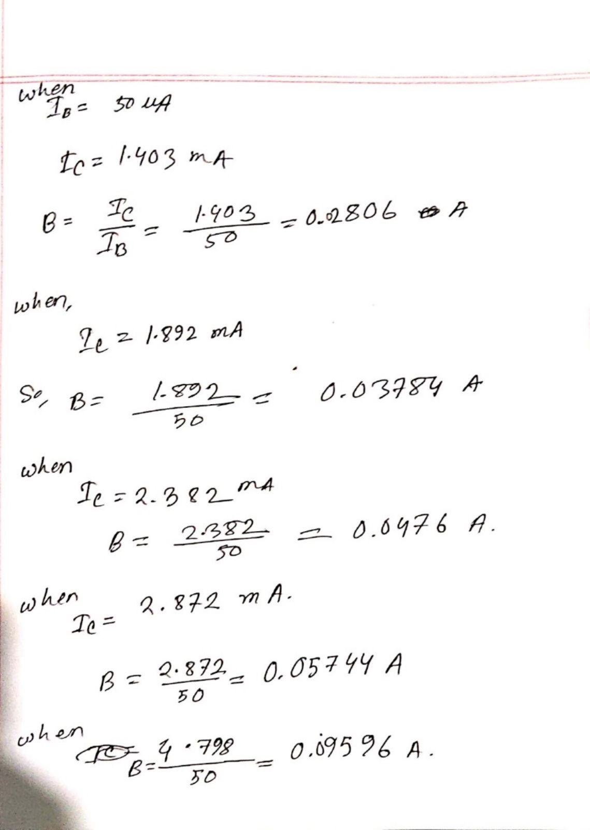

**Answer to question 4:**

Calculation to get the Load Line for VCC = 15V:

ICmax = VCC/RC where, VCE = 0V [VCE = VCC - ICRC]

So, ICmax = 15V/1kΩ = 15mA

& VCEmax = VCC where, IC = 0A

So, VCEmax = 15V

For VCC = 15V, drawing the load line:

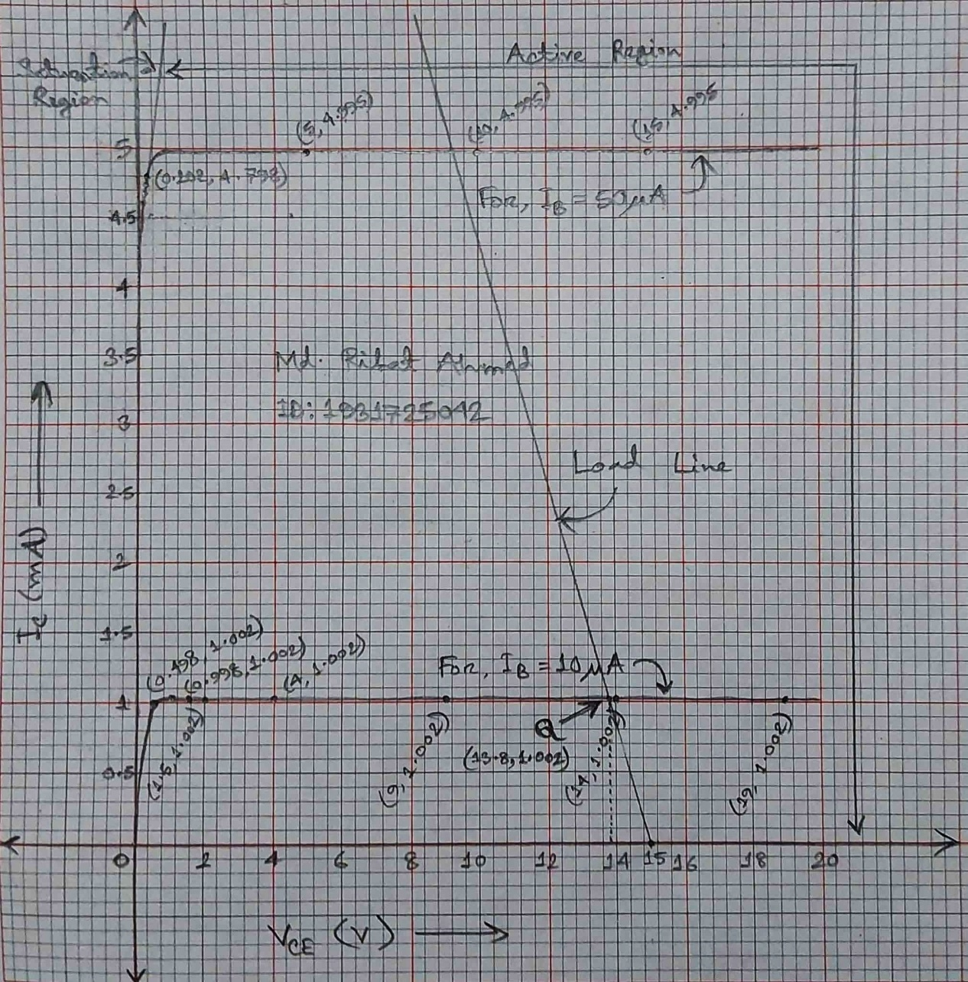

From the Graph we get the Q-Point: (13.8V, 1.002mA)

**Answer to question 5:**

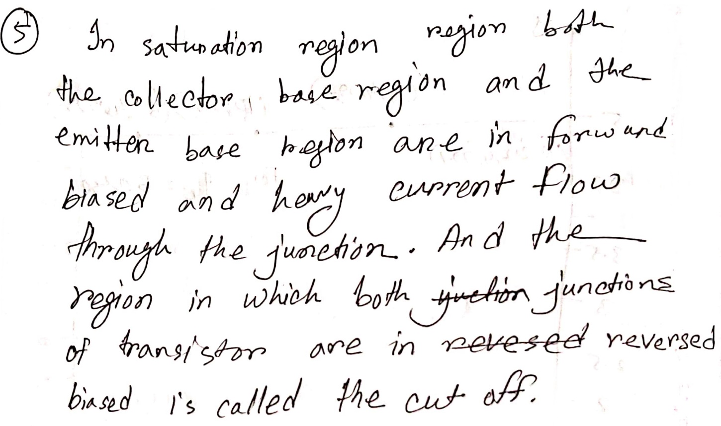

**Answer to question 6:**

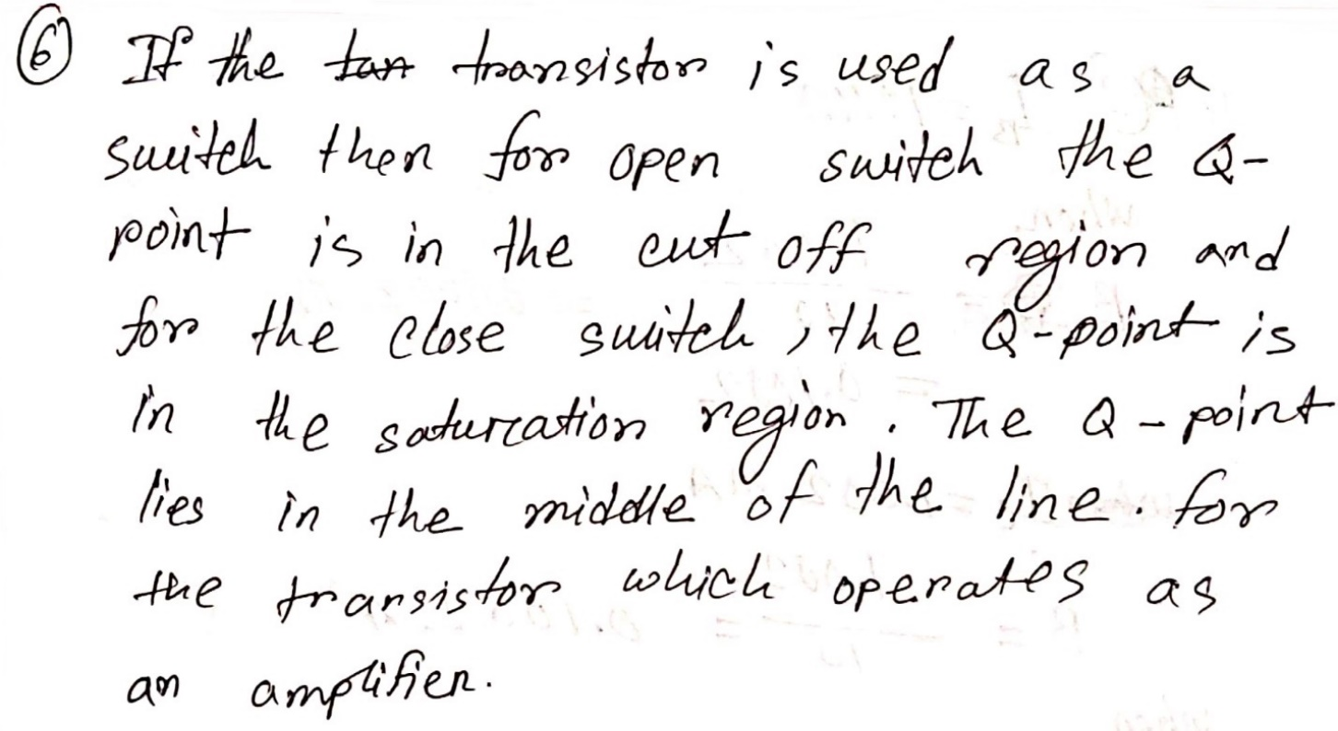

**Contributions:**

|  |  |
| --- | --- |
| **Name & ID** | **Contribution** |
| Md. Rifat Ahmed – 1931725042  (**Report Writer)** | Data & Table, Graphs,  Attachment |
| Yusuf Abdullah Tonmoy – 1620456042 | Circuit Diagram |
| Fardin Bin Islam - 1721588642 | Theory, Equipment List |
| Md Kawser Islam – 1912296642 | Questions/Answers |
| Tusher Saha Nirjhor - 1921793642 | Result Analysis & Discussion |

**Attachment:**

**Task 01:**

### Table 1: Input Characteristics of BJT

|  |  |  |  |  |  |  |  |
| --- | --- | --- | --- | --- | --- | --- | --- |
| $V_{CE }$ = 1 V | | | | $V_{CE }$ = 5V | | | |
| $V_{BB}$**(Volts)** | $V_{BE }$**(Volts)** | $V_{RB }$**(Volts)** | $${ I}_{B}=V_{RB }/R_{B}$$ (**μA)** | $V_{BB}$**(Volts)** | $V_{BE }$**(Volts)** | $V_{RB }$**(Volts)** | $${ I}_{B}=V_{RB }/R_{B}$$ (**μA)** |
| 0.1 | 100mV | 0V | 0A | 0.1 | 100mV | 0V | 0A |
| 0.2 | 200mV | 0V | 0A | 0.2 | 200mV | 0V | 0A |
| 0.3 | 300mV | 0V | 0A | 0.3 | 300mV | 0V | 0A |
| 0.5 | 200mV | 24.844mV | 0A | 0.5 | 500mV | 24.444mV | 0A |
| 0.7 | 677mV | 23.168mV | 0A | 0.7 | 677mV | 23.168mV | 0A |
| 1.0 | 739mV | 260.573mV | 2.61µA | 1.0 | 739mV | 260.573mV | 2.61µA |
| 3 | 795mV | 2.205V | 22.1µA | 3 | 795mV | 2.205V | 22.1µA |
| 5 | 811mV | 4.189V | 41.9µA | 5 | 811mV | 4.189V | 41.9µA |
| 7 | 821mV | 6.179V | 61.8µA | 7 | 821mV | 6.179V | 61.8µA |
| 10 | 832mV | 9.168V | 91.7µA | 10 | 832mV | 9.168V | 91.7µA |
| 14 | 841mV | 13.159V | 132µA | 14 | 841mV | 13.159V | 132µA |

Here, we’re considering 0V and 0A for values that are too small like nV, pA, nA.

**Table 2: Output Characteristics of BJT**

|  |  |  |  |  |  |  |
| --- | --- | --- | --- | --- | --- | --- |
|  | ${ I}_{B}$ = 10 **μA** | | | ${ I}_{B}$ = 50 **μA** | | |
| $V_{CC}$**(Volts)** | $V_{CE }$**(Volts)** | $V_{RC }$**(Volts)** | $${ I}_{C}=V_{RC }/R_{BC}$$ (**mA)** | $V_{CE }$**(Volts)** | $V_{RC }$**(Volts)** | $${ I}_{C}=V_{RC }/R_{BC}$$ (**mA)** |
| 0.1 | 51.2mV | 48.81mV | 48.81A | 31.7mV | 68.252mV | 68.252µA |
| 0.3 | 87.5mV | 212.479mV | 212.479µA | 51.6mV | 248.45mV | 248.45µA |
| 0.5 | 109mV | 391.104mV | 391.104µA | 63.8mV | 436.23mV | 436.23µA |
| 0.7 | 128mV | 572.499mV | 572.499µA | 72.7mV | 627.274mV | 627.274µA |
| 0.9 | 148mV | 751.58mV | 751.58µA | 80.0mV | 820.026mV | 820.026µA |
| 1.0 | 162mV | 837.847mV | 837.847µA | 83.2mV | 916.834mV | 916.834µA |
| 1.2 | 219mV | 981.124mV | 981.124µA | 89.0mV | 1.111V | 1.111mA |
| 1.5 | 498mV | 1.002V | 1.002mA | 96.6mV | 1.403V | 1.403mA |
| 2.0 | 998mV | 1.002V | 1.002mA | 108mV | 1.892V | 1.892mA |
| 2.5 | 1.5V | 1.002V | 1.002mA | 118mV | 2.382V | 2.382mA |
| 3.0 | 2.0V | 1.002V | 1.002mA | 128mV | 2.872V | 2.872mA |
| 5.0 | 4.0V | 1.002V | 1.002 mA | 202mV | 4.798V | 4.798mA |
| 10.0 | 9.0V | 1.002V | 1.002mA | 5.0V | 4.995V | 4.995mA |
| 15.0 | 14.0V | 1.002V | 1.002mA | 10.0V | 4.995V | 4.995mA |
| 20.0 | 19.0V | 1.002V | 1.002mA | 15.0V | 4.995V | 4.995mA |

**Task 02:**

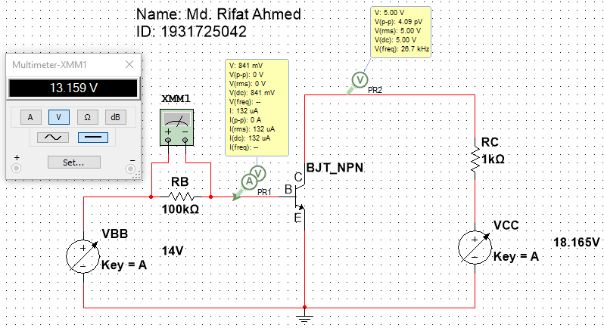

Figure 1 – Circuit to get the values for the Input characteristics of BJT

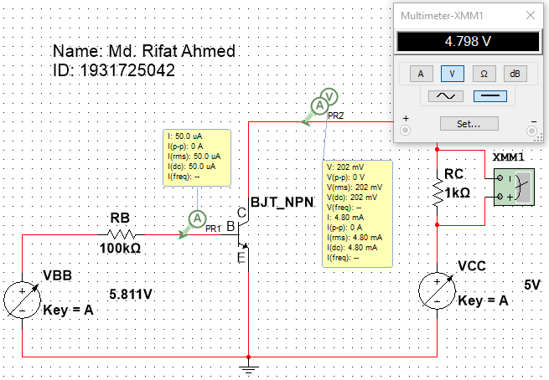

Figure 2 – Circuit to get the values for the Output characteristics of BJT

**Task 03:**



Figure 3 – Input Characteristics Graph of BJT for VCE = 1V & 5V

Here, we got the same values of IB and VBE for the given points for both VCE = 1V & 5V while simulating so the same line is representating both of them.



Figure 4 – Output Characteristics Graph of BJT for IB = 10µA & 50µA

**References:**

[Common Emitter Connection (or CE Configuration) - Input & Output Characteristic Curve - Circuit Globe](https://circuitglobe.com/common-emitter-connection-or-ce-configuration.html) –

https://circuitglobe.com/common-emitter-connection-or-ce-configuration.html